**Testable Solutions**

By Mousfiqul Islam Khan

1. Positioning Statement

For the Enterprise as a whole:

NyGen (IT company, provides IT support to other businesses reducing their need to have an IT department for themselves). Unlike other firms who provide IT services on a contractual basis, NyGen acts as a permanent consultant. They have various clients from small firms to big corporations, providing either an extra assistance to any IT related issues, or sometimes they handle all of the IT related problems faced by the business.

For their Digital Platform:

For IT technicians who work at NyGen, NyApp is an enterprise software that will improve their ability to be more efficient on field jobs and enhance the maintenance experience overall. Unlike the current solution where technicians have to call back and wait for answers to queries, NyApp gives the technicians the ability to easily find what they are looking for, and drastically improve both technician and customer experience.

1. Demand/Value Hypothesis

|  |  |  |
| --- | --- | --- |
| Problem Scenario | Current Alternatives | Demand/Value Hypothesis |
| Search for all prices and documentation from a single platform. | Currently technicians have to search in all platforms individually. | If we provide a way to search for all documents, then the techs will use it and it will improve outcome. |
| Doesn’t have to put in his credentials in each platform every time a technician tries to find documents. | Currently technicians have to log in every time they have to look for prices to make estimations. | If we provide a way with which employees can search for all the content on a single platform then it will save time and confusion. |

1. Testable Solution for Demand/Value Hypothesis:
   1. Epic User Stories:
2. As Todd the IT technician, I want to know the pricing and availability of products and services.
3. As Todd the IT technician, I want to have a map to track my job locations.
   1. Storyboard for Epic a:

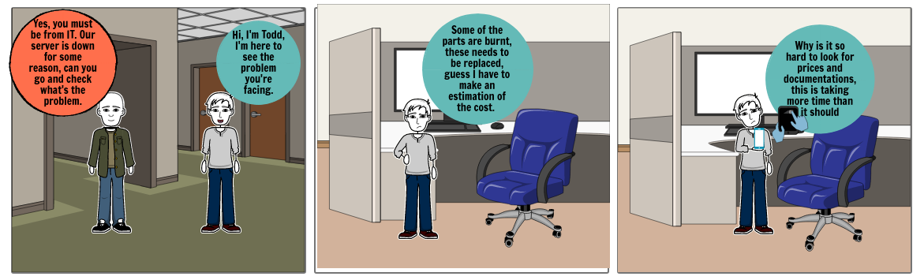

* 1. Child Stories and Analytics for Epic a:

|  |  |  |
| --- | --- | --- |
| Child Stories | Analytical Question(s) | Analytics |
| I know the part and service name, I want to find it on the system to check the price. | Check how many times this search feature is used compared to the alternatives.  How many times does this search lead to a part of service order? | Metrics:  - This type of searches compared to others.  - Pattern of these searches compared to others.  - (%) of the Conversion to order from these type of searches. |
| I would also want a mechanism to filter products and services based on price and quality. | Check how often the filter is used for price and quality also compare each with the alternatives.  How many times does a search by either price or quality lead to an order? | Metrics:  - This type of searches compared to others.  - Pattern of these searches compared to others.  - (%) of the Conversion to order from these type of searches. |